#
# 20190109 SD#2142832 Server vm-mvno-zbx01p not send emails to outside
#
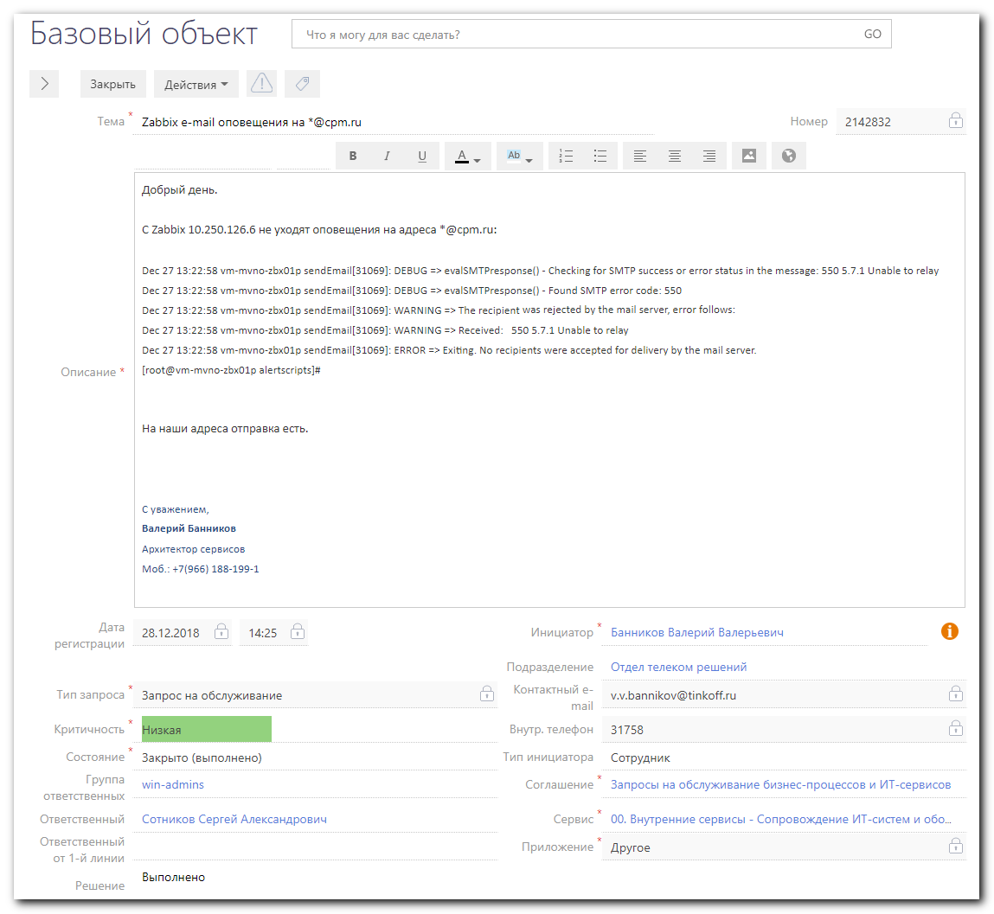
................................................................................

Добрый день.

С Zabbix 10.250.126.6 не уходят оповещения на адреса *@cpm.ru:

Dec 27 13:22:58 vm-mvno-zbx01p sendEmail[31069]: DEBUG => evalSMTPresponse() - Checking for SMTP success or error status in the message: 550 5.7.1 Unable to relay

Dec 27 13:22:58 vm-mvno-zbx01p sendEmail[31069]: DEBUG => evalSMTPresponse() - Found SMTP error code: 550

Dec 27 13:22:58 vm-mvno-zbx01p sendEmail[31069]: WARNING => The recipient <d.nepochatykh@cpm.ru> was rejected by the mail server, error follows:

Dec 27 13:22:58 vm-mvno-zbx01p sendEmail[31069]: WARNING => Received: 550 5.7.1 Unable to relay

Dec 27 13:22:58 vm-mvno-zbx01p sendEmail[31069]: ERROR => Exiting. No recipients were accepted for delivery by the mail server.

[root@vm-mvno-zbx01p alertscripts]#

На наши адреса отправка есть.

................................................................................

[root@vm-mvno-zbx01p ~]# zabbix_server --version
zabbix_server (Zabbix) 3.4.8
Revision 79252 3 April 2018, compilation time: Apr 3 2018 11:20:44

Copyright (C) 2018 Zabbix SIA
License GPLv2+: GNU GPL version 2 or later <http://gnu.org/licenses/gpl.html>.
This is free software: you are free to change and redistribute it according to
the license. There is NO WARRANTY, to the extent permitted by law.
[root@vm-mvno-zbx01p ~]#

................................................................................

[root@vm-mvno-zbx01p ~]# cat /etc/redhat-release
CentOS Linux release 7.4.1708 (Core)
[root@vm-mvno-zbx01p ~]#

[root@vm-mvno-zbx01p ~]# cat /etc/zabbix/zabbix_server.conf | grep AlertScriptsPath
### Option: AlertScriptsPath
# AlertScriptsPath=${datadir}/zabbix/alertscripts
AlertScriptsPath=/usr/lib/zabbix/alertscripts
[root@vm-mvno-zbx01p ~]# ls -Alh /usr/lib/zabbix/alertscripts
total 12K
-rwxr-xr-x. 1 root root 167 May 22 2018 notify-by-nagsms.sh
-rwxr-xr-x. 1 root root 357 Dec 27 13:21 send-email.sh
-rwxr-xr-x. 1 root root 943 May 22 2018 sms_mfm.sh
[root@vm-mvno-zbx01p ~]#

[root@vm-mvno-zbx01p ~]# cat /usr/lib/zabbix/alertscripts/send-email.sh
#!/bin/sh

export smtpemailfrom=hlr_alarm@tinkoff.ru
export zabbixemailto=$1
export zabbixsubject=$2
export zabbixbody=$3
export smtpserver=smtp.tcsbank.ru
export smtplogin=hlr_alarm
export smtppass=6}2GJlO0*BUuwxb

/usr/bin/sendEmail -f $smtpemailfrom -t $zabbixemailto -u $zabbixsubject -m $zabbixbody -s $smtpserver:25 -xu $smtplogin -xp $smtppass -vvv
[root@vm-mvno-zbx01p ~]#

[root@vm-mvno-zbx01p ~]# rpm -qf /usr/bin/sendEmail
sendemail-1.56-1.el7.noarch
[root@vm-mvno-zbx01p ~]#

[root@vm-mvno-zbx01p ~]# grep -ire 'sendEmail' /var/log/
/var/log/messages-20181230:Dec 27 13:22:51 vm-mvno-zbx01p yum[30858]: Installed: sendemail-1.56-1.el7.noarch
/var/log/yum.log-20190101:Dec 27 13:22:51 Installed: sendemail-1.56-1.el7.noarch
[root@vm-mvno-zbx01p ~]#

[root@vm-mvno-zbx01p ~]# ls -Alh /var/log/maillog*
-rw-------. 1 root root 0 Jan 7 03:27 /var/log/maillog
-rw-------. 1 root root 0 Dec 10 03:30 /var/log/maillog-20181216
-rw-------. 1 root root 0 Dec 16 03:14 /var/log/maillog-20181223
-rw-------. 1 root root 0 Dec 23 03:25 /var/log/maillog-20181230
-rw-------. 1 root root 0 Dec 30 03:45 /var/log/maillog-20190107
[root@vm-mvno-zbx01p ~]#

................................................................................

[root@vm-mvno-zbx01p ~]# read -s smtppass ; export smtppass
[root@vm-mvno-zbx01p ~]# smtpemailfrom=hlr_alarm@tinkoff.ru ; smtpserver=smtp.tcsbank.ru ; smtplogin=hlr_alarm ; /usr/bin/sendEmail -f $smtpemailfrom -t "s.belogrud@tinkoff.ru" -u "test_from_vm-mvno-zbx01
p" -m "test_from_vm-mvno-zbx01p" -s $smtpserver:25 -xu $smtplogin -xp $smtppass -vvv
Jan 09 12:38:36 vm-mvno-zbx01p sendEmail[1650]: DEBUG => Connecting to smtp.tcsbank.ru:25
Jan 09 12:38:36 vm-mvno-zbx01p sendEmail[1650]: DEBUG => My IP address is: 10.250.126.6
Jan 09 12:38:36 vm-mvno-zbx01p sendEmail[1650]: DEBUG => evalSMTPresponse() - Checking for SMTP success or error status in the message: 220 ds-msk-mail1301.tcsbank.ru Microsoft ESMTP MAIL Service ready at Wed, 9 Jan 2019 12:38:35 +0300
Jan 09 12:38:36 vm-mvno-zbx01p sendEmail[1650]: DEBUG => evalSMTPresponse() - Found SMTP success code: 220
Jan 09 12:38:36 vm-mvno-zbx01p sendEmail[1650]: SUCCESS => Received: 220 ds-msk-mail1301.tcsbank.ru Microsoft ESMTP MAIL Service ready at Wed, 9 Jan 2019 12:38:35 +0300
Jan 09 12:38:36 vm-mvno-zbx01p sendEmail[1650]: INFO => Sending: EHLO vm-mvno-zbx01p.tcsbank.ru
Jan 09 12:38:36 vm-mvno-zbx01p sendEmail[1650]: DEBUG => evalSMTPresponse() - Checking for SMTP success or error status in the message: 250-ds-msk-mail1301.tcsbank.ru Hello [10.219.0.235], 250-SIZE 52428800, 250-PIPELINING, 250-DSN, 250-ENHANCEDSTATUSCODES, 250-8BITMIME, 250-BINARYMIME, 250 CHUNKING
Jan 09 12:38:36 vm-mvno-zbx01p sendEmail[1650]: DEBUG => evalSMTPresponse() - Found SMTP success code: 250
Jan 09 12:38:36 vm-mvno-zbx01p sendEmail[1650]: SUCCESS => Received: 250-ds-msk-mail1301.tcsbank.ru Hello [10.219.0.235], 250-SIZE 52428800, 250-PIPELINING, 250-DSN, 250-ENHANCEDSTATUSCODES, 250-8BITMIME, 250-BINARYMIME, 250 CHUNKING
Jan 09 12:38:36 vm-mvno-zbx01p sendEmail[1650]: DEBUG => The remote SMTP server does NOT support TLS :(
Jan 09 12:38:36 vm-mvno-zbx01p sendEmail[1650]: NOTICE => Authentication not supported by the remote SMTP server!
Jan 09 12:38:36 vm-mvno-zbx01p sendEmail[1650]: INFO => Sending: MAIL FROM:<hlr_alarm@tinkoff.ru>
Jan 09 12:38:36 vm-mvno-zbx01p sendEmail[1650]: DEBUG => evalSMTPresponse() - Checking for SMTP success or error status in the message: 250 2.1.0 Sender OK
Jan 09 12:38:36 vm-mvno-zbx01p sendEmail[1650]: DEBUG => evalSMTPresponse() - Found SMTP success code: 250
Jan 09 12:38:36 vm-mvno-zbx01p sendEmail[1650]: SUCCESS => Received: 250 2.1.0 Sender OK
Jan 09 12:38:36 vm-mvno-zbx01p sendEmail[1650]: INFO => Sending: RCPT TO:<s.belogrud@tinkoff.ru>
Jan 09 12:38:36 vm-mvno-zbx01p sendEmail[1650]: DEBUG => evalSMTPresponse() - Checking for SMTP success or error status in the message: 250 2.1.5 Recipient OK
Jan 09 12:38:36 vm-mvno-zbx01p sendEmail[1650]: DEBUG => evalSMTPresponse() - Found SMTP success code: 250
Jan 09 12:38:36 vm-mvno-zbx01p sendEmail[1650]: SUCCESS => Received: 250 2.1.5 Recipient OK
Jan 09 12:38:36 vm-mvno-zbx01p sendEmail[1650]: INFO => Sending: DATA
Jan 09 12:38:36 vm-mvno-zbx01p sendEmail[1650]: DEBUG => evalSMTPresponse() - Checking for SMTP success or error status in the message: 354 Start mail input; end with <CRLF>.<CRLF>
Jan 09 12:38:36 vm-mvno-zbx01p sendEmail[1650]: DEBUG => evalSMTPresponse() - Found SMTP success code: 354
Jan 09 12:38:36 vm-mvno-zbx01p sendEmail[1650]: SUCCESS => Received: 354 Start mail input; end with <CRLF>.<CRLF>
Jan 09 12:38:36 vm-mvno-zbx01p sendEmail[1650]: INFO => Sending message body
Jan 09 12:38:36 vm-mvno-zbx01p sendEmail[1650]: Setting content-type: text/plain
Jan 09 12:38:36 vm-mvno-zbx01p sendEmail[1650]: DEBUG => evalSMTPresponse() - Checking for SMTP success or error status in the message: 250 2.6.0 <397209.624151827-sendEmail@vm-mvno-zbx01p> [InternalId=3285649989867, Hostname=ds-msk-mail1313.tcsbank.ru] Queued mail for delivery
Jan 09 12:38:36 vm-mvno-zbx01p sendEmail[1650]: DEBUG => evalSMTPresponse() - Found SMTP success code: 250
Jan 09 12:38:36 vm-mvno-zbx01p sendEmail[1650]: SUCCESS => Received: 250 2.6.0 <397209.624151827-sendEmail@vm-mvno-zbx01p> [InternalId=3285649989867, Hostname=ds-msk-mail1313.tcsbank.ru] Queued mail for delivery
Jan 09 12:38:36 vm-mvno-zbx01p sendEmail[1650]: Generating a detailed exit message
Jan 09 12:38:36 vm-mvno-zbx01p sendEmail[1650]: Email was sent successfully! From: <hlr_alarm@tinkoff.ru> To: <s.belogrud@tinkoff.ru> Subject: [test_from_vm-mvno-zbx01p] Server: [smtp.tcsbank.ru:25]
[root@vm-mvno-zbx01p ~]#

[root@vm-mvno-zbx01p ~]# smtpemailfrom=hlr_alarm@tinkoff.ru ; smtpserver=smtp.tcsbank.ru ; smtplogin=hlr_alarm ; /usr/bin/sendEmail -f $smtpemailfrom -t "d.nepochatykh@cpm.ru" -u "test_from_vm-mvno-zbx01p
" -m "test_from_vm-mvno-zbx01p" -s $smtpserver:25 -xu $smtplogin -xp $smtppass -vvv
Jan 09 12:43:10 vm-mvno-zbx01p sendEmail[4794]: DEBUG => Connecting to smtp.tcsbank.ru:25
Jan 09 12:43:10 vm-mvno-zbx01p sendEmail[4794]: DEBUG => My IP address is: 10.250.126.6
Jan 09 12:43:10 vm-mvno-zbx01p sendEmail[4794]: DEBUG => evalSMTPresponse() - Checking for SMTP success or error status in the message: 220 ds-msk-mail1302.tcsbank.ru Microsoft ESMTP MAIL Service ready at Wed, 9 Jan 2019 12:43:11 +0300
Jan 09 12:43:10 vm-mvno-zbx01p sendEmail[4794]: DEBUG => evalSMTPresponse() - Found SMTP success code: 220
Jan 09 12:43:10 vm-mvno-zbx01p sendEmail[4794]: SUCCESS => Received: 220 ds-msk-mail1302.tcsbank.ru Microsoft ESMTP MAIL Service ready at Wed, 9 Jan 2019 12:43:11 +0300
Jan 09 12:43:10 vm-mvno-zbx01p sendEmail[4794]: INFO => Sending: EHLO vm-mvno-zbx01p.tcsbank.ru
Jan 09 12:43:10 vm-mvno-zbx01p sendEmail[4794]: DEBUG => evalSMTPresponse() - Checking for SMTP success or error status in the message: 250-ds-msk-mail1302.tcsbank.ru Hello [10.219.0.226], 250-SIZE 52428800, 250-PIPELINING, 250-DSN, 250-ENHANCEDSTATUSCODES, 250-8BITMIME, 250-BINARYMIME, 250 CHUNKING
Jan 09 12:43:10 vm-mvno-zbx01p sendEmail[4794]: DEBUG => evalSMTPresponse() - Found SMTP success code: 250
Jan 09 12:43:10 vm-mvno-zbx01p sendEmail[4794]: SUCCESS => Received: 250-ds-msk-mail1302.tcsbank.ru Hello [10.219.0.226], 250-SIZE 52428800, 250-PIPELINING, 250-DSN, 250-ENHANCEDSTATUSCODES, 250-8BITMIME, 250-BINARYMIME, 250 CHUNKING
Jan 09 12:43:10 vm-mvno-zbx01p sendEmail[4794]: DEBUG => The remote SMTP server does NOT support TLS :(
Jan 09 12:43:10 vm-mvno-zbx01p sendEmail[4794]: NOTICE => Authentication not supported by the remote SMTP server!
Jan 09 12:43:10 vm-mvno-zbx01p sendEmail[4794]: INFO => Sending: MAIL FROM:<hlr_alarm@tinkoff.ru>
Jan 09 12:43:10 vm-mvno-zbx01p sendEmail[4794]: DEBUG => evalSMTPresponse() - Checking for SMTP success or error status in the message: 250 2.1.0 Sender OK
Jan 09 12:43:10 vm-mvno-zbx01p sendEmail[4794]: DEBUG => evalSMTPresponse() - Found SMTP success code: 250
Jan 09 12:43:10 vm-mvno-zbx01p sendEmail[4794]: SUCCESS => Received: 250 2.1.0 Sender OK
Jan 09 12:43:10 vm-mvno-zbx01p sendEmail[4794]: INFO => Sending: RCPT TO:<d.nepochatykh@cpm.ru>
Jan 09 12:43:15 vm-mvno-zbx01p sendEmail[4794]: DEBUG => evalSMTPresponse() - Checking for SMTP success or error status in the message: 550 5.7.1 Unable to relay
Jan 09 12:43:15 vm-mvno-zbx01p sendEmail[4794]: DEBUG => evalSMTPresponse() - Found SMTP error code: 550
Jan 09 12:43:15 vm-mvno-zbx01p sendEmail[4794]: WARNING => The recipient <d.nepochatykh@cpm.ru> was rejected by the mail server, error follows:
Jan 09 12:43:15 vm-mvno-zbx01p sendEmail[4794]: WARNING => Received: 550 5.7.1 Unable to relay
Jan 09 12:43:15 vm-mvno-zbx01p sendEmail[4794]: ERROR => Exiting. No recipients were accepted for delivery by the mail server.
[root@vm-mvno-zbx01p ~]#

................................................................................

https://habr.com/post/267523/
Настройка отправки почтовых уведомлений в Zabbix на CentOS 7

https://serveradmin.ru/nastroyka-email-opoveshheniy-v-zabbix/
Отправка email уведомлений в zabbix 2.4

................................................................................

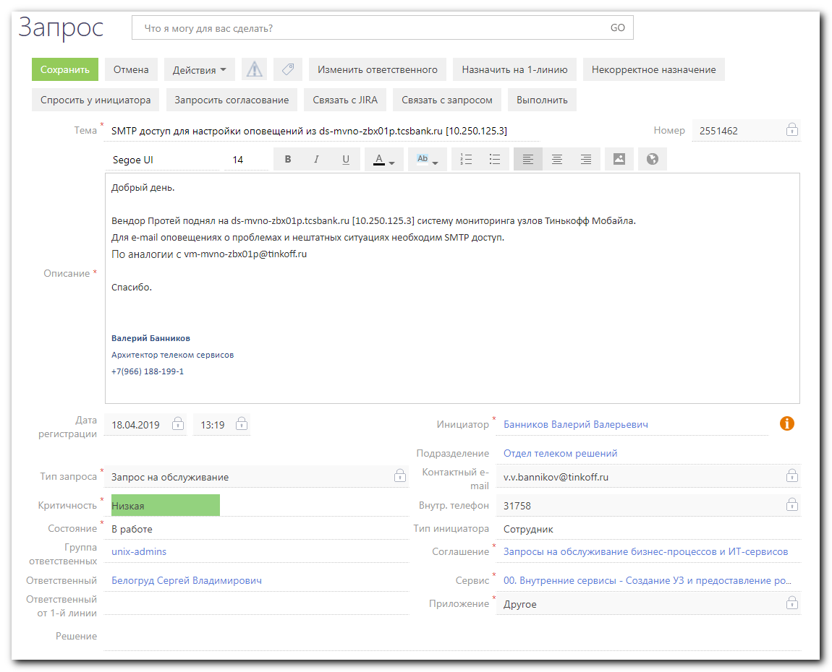

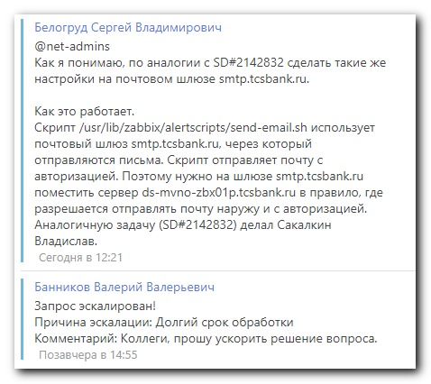
Белогруд Сергей Владимирович
@net-admins
Как я понимаю, по аналогии с SD#2142832 сделать такие же настройки на почтовом шлюзе smtp.tcsbank.ru.

Как это работает.
Скрипт /usr/lib/zabbix/alertscripts/send-email.sh использует почтовый шлюз smtp.tcsbank.ru, через который отправляются письма. Скрипт отправляет почту с авторизацией. Поэтому нужно на шлюзе smtp.tcsbank.ru поместить сервер ds-mvno-zbx01p.tcsbank.ru в правило, где разрешается отправлять почту наружу и с авторизацией. Аналогичную задачу (SD#2142832) делал Сакалкин Владислав.

Сегодня в 12:21

